**This is a demonstration of MyTime validation:**

Sets of data to test with  
  
There are only two places to ENTER data in on my app, the timer (how long you want to set the timer for) and the alarm (when you want the alarm to go off)  
  
To test the timer I just entered a **1 minute** timer so I didn’t have to wait that long:  
  


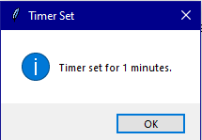

And sure enough in1 minute this is what happened:

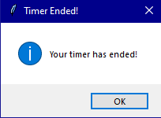

So judging by this, the timer works.  
  
To test the alarm, I then set an Alarm for 10:20 because it is 10:18 as i am writing this message

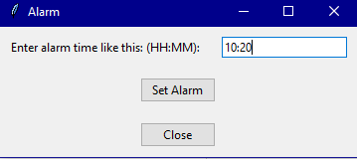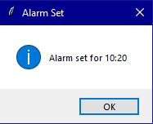

And sure enough at 10:20 this happened

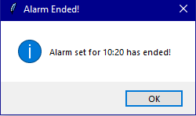

So based off this, the alarm also works.  
  
I had to fix nothing, it worked as expected the program works.